**Economic Efficiency:**

For an economic efficiency to occur goods and services need to be produced using the least amount of resources as possible, and with a stated quality (Engineering Efficiency), and this is not enough, for these goods and services to be economically efficient resources must be allocated to satisfy society’s wants as fully as possible.

**FIRMS:**

Firms are profit maximizers, which means all firms allocate their resources to achieve maximum profit, and produce what consumer want, or else they will not be able to sell their output “outputs are optimized as per consumer preferences and taste”.

In the other hand in competitive market for factor inputs, firms will hire resources up to the point where Price/ Wage = Value Of Marginal Product (VMP) for the factor input, and the demand for the factor input is dependent on the demand of the Final goods and services it produces.

This is why a scarce talent gets high Wage/income, for example a famous singer command high economic rent, in the same time receives high income because of the high demand on his scarce talent.

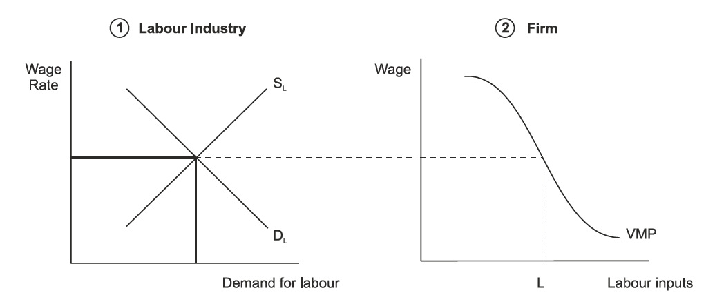

**Households:**

Households are profit maximizers as well, since they allocate their income so that $\frac{Mu}{P}a=\frac{Mu}{P}b$ = $\frac{Mu}{P}c….$ for all their expenditure, so that the last $ spent on good a return the same utility as the last $ spent on good b, c and so on.

If in any case $\frac{Mu}{P}a>\frac{Mu}{P}b$ > $\frac{Mu}{P}c$ then the law of diminishing marginal utility kicks in to adjust any imbalance, as the increase in the consumption of a good will decrease the utility received for each unit consumed, and we will be back to balance and economic efficiency.

**Opportunity Cost:**

People will choose their education based on factors like skills, talents and “Opportunity Cost”, Doctor Vs. Technician, a doctor is better paid but on the other hand the time and money invested in a doctor is much more than that in a technician, and the market will reward people based on their skills, how scarce are their skills, and what is the demand on that skill.

**Marginal Equivalency Conditions (MEC):**

Since competitive firms are price takers P (Price) = MC (Marginal Cost), so

$\frac{Mu}{Mc}a=\frac{Mu}{Mc}b$ = $\frac{Mu}{Mc}c$, the MEC is in Equilibrium and the Economic efficiency prevails.

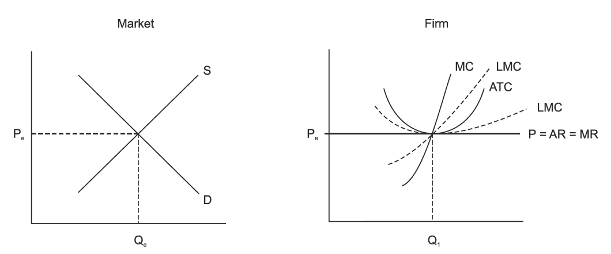

In real world MEC may never be attained but it is where the economy is heading, though market is not always perfect for the following reasons:

* Information may be missing
* New goods and services constantly introduced in the market
* Technological changes
* Exogenous shocks
* Imperfection of the market system:
  + Public goods
  + Externalities
  + Economies of scale
  + Distribution of income

Each of which require government intervention to restore economic efficiency

Government intervention can be through the following:

* + - Direct legislation: imposing a tax or subsidy, or laws and regulations to bring the economy to the point of economic efficiency (ex: to make the producer bare the societal cost not only the private one in the case of negative externality )
    - Indirect Legislation: through defining clear property rights for the externalities.
    - Internalize the externality (when external cost or benefit are brought within the scope of single organization)

There are instances where MEC do not hold as the case of Market failure,

* Market failure occur when the market fails to allocate resources to the production of goods and services in an economic efficient manner like in the following cases:

**Economies of Scale:**

Economies of scale arise when the output increases average cost per unit falls, this could arise from specialization of labor.

Monopolies tend to arise (sole producer of good or service), entry barriers may be very high due to patent or high level required of capital stock! (Too expensive to produce like Cars industries).

Our problem with monopolies is that they have the power to set the price P > Mc, resulting in inefficient allocation of society’s resources and reduce economic efficiency $\frac{Mu}{Mc}mono>\frac{Mu}{Mc}other goods$

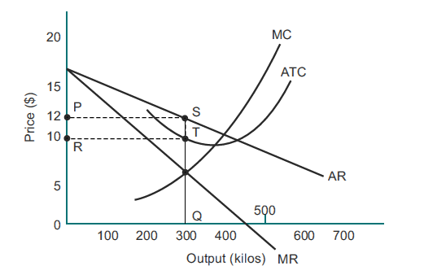

Government intervention is required to deal with the monopolist:

* Set price to = Mc, and LRMC to achieve Economic efficiency.
* If above normal profits still exist after setting the new price🡪 imposes a tax.
* If under normal profit resulted after setting the new price🡪 give subsidies.
* Or we can break up the Monopoly.

The problem with these solutions is that the Monopolist has no incentive to actually operate at economically efficient manner.

**Externalities:**

Involve cost or benefit occurring to a party not involved in the economic activity, and the societal cost/ Benefit is higher than the private cost/ benefit, so the MEC’s will not hold

Ex: a factory dumping his waist in the river, in perfect market the factory owner will not take into account the cost of lost fishes and his private cost of production will be less than the societal cost, so MEC’s will not hold, and economic efficiency will not prevail . $\frac{Mu}{Mc}factory production>\frac{Mu}{Mc}other goods$

Government intervention is required:

* To force the producer to take the full societal costs by imposing a tax on each unit produced.(Direct legislation)
* Or by property rights to either the factory or the fishermen (indirect legislation)

Other Ex: maybe +ve Externality like someone privately building light house, other can use without paying for it (the Free Rider problem), in this case $\frac{Mu}{Mc}LH>\frac{Mu}{Mc}other goods$ Government should provide subsidy for him to achieve economic efficiency.

**Public Goods:**

Are goods that are non-excludable and non-rivalry, means no one can be excluded from using it and one’s use does not diminish another’s “Opposite of Private goods”

And goods that might be enjoyed by anyone without having to pay for it “the Free Rider Problem”

Ex: street light and National defense, under perfect market conditions those will not be produced in optimal quantities, collective action is required by the government to produce those goods to the point where $\frac{MSB}{MSC}a=\frac{MSB}{MSC}b=\frac{MSB}{MSC}c=…$ for all public goods produced is equal.

**Distribution of Income:**

Market System produces inequitable distribution of income (Lorenz Curve)

Government steps in to redistribute income by imposing a tax on income to ensure that the minimum standard of living is achieved for all, of course this is an issue of Equity rather than Efficiency.

A progressive tax system, where richer people pay more Value and more percentage of their income than the poor is set in place by the government to redistribute income.

The wealth of an individual in an Economy is determined by the amount of resources they own, like labor, they lend it to firms and earns Income/Wage in return; this income is determined by the forces of demand and supply.